Document Uploader
Guide

Website Version:

- Log on to SFCU website and proceed to Login Area.
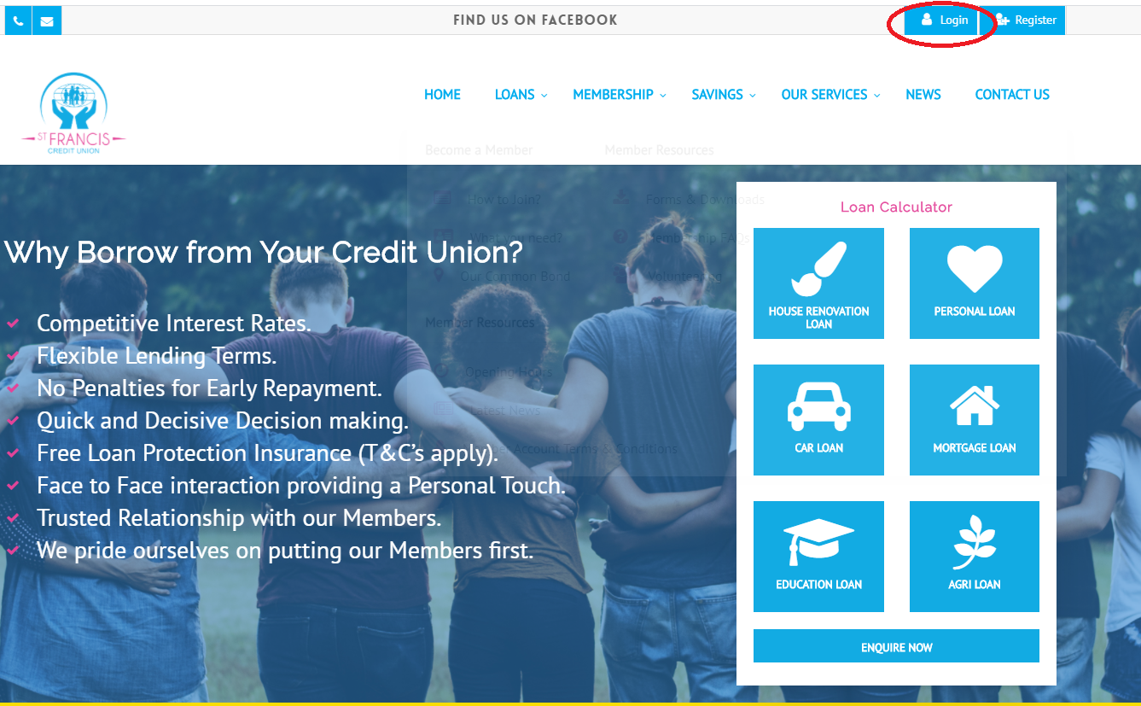
- Log in with member details to the main Members Area

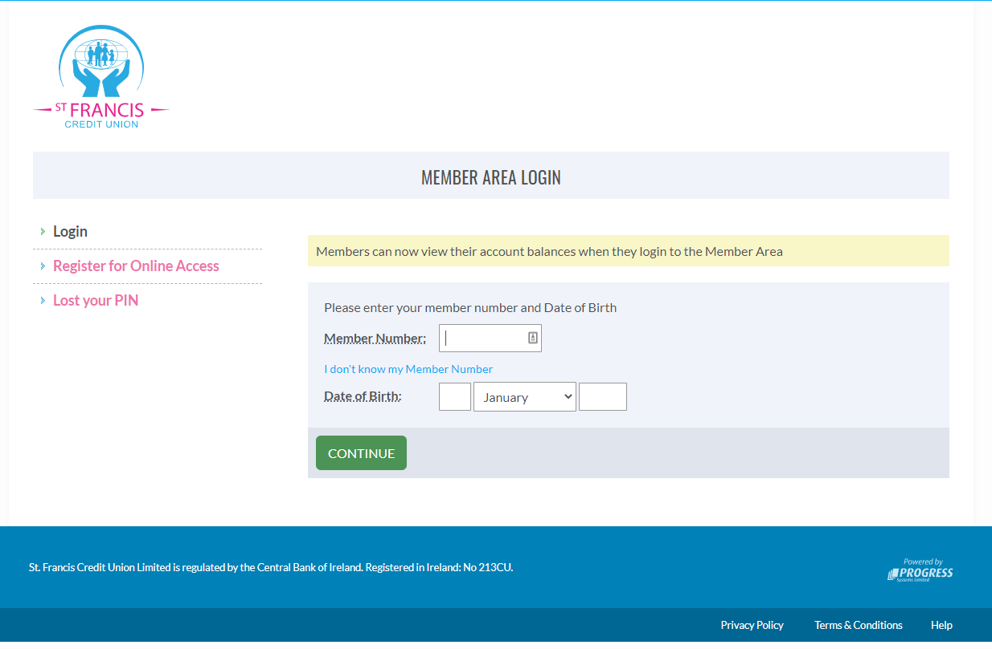
- Launch the online banking section
  - Launch either with the blue “online banking” button on the left of the pink “launch now” button in the centre
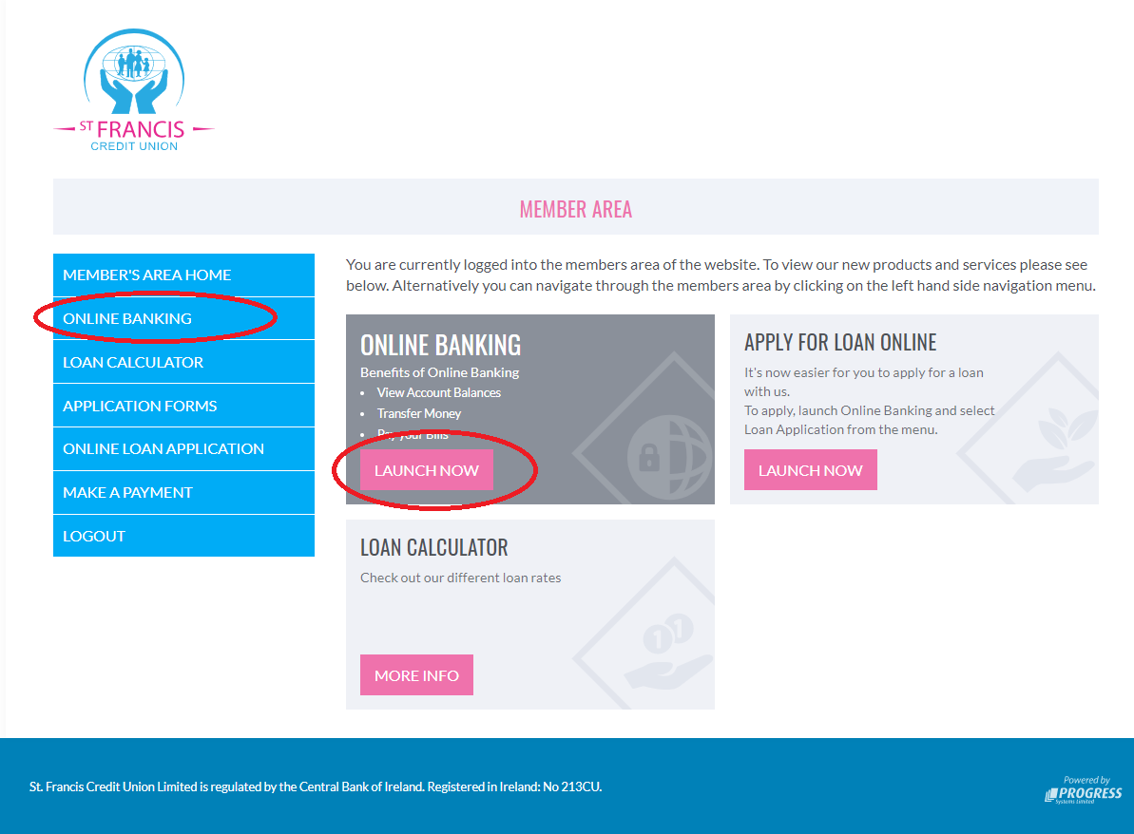

- Once logged into the online banking area the member can then select the blue “Document Upload” button.
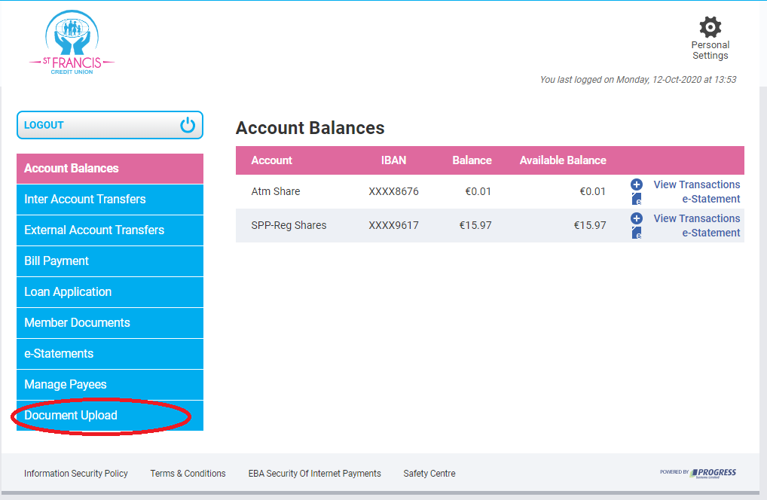
- Member can now select the file they would like to upload and the document type related to this file
  - i.e. – file is a wage slip and document type is Proof of Income

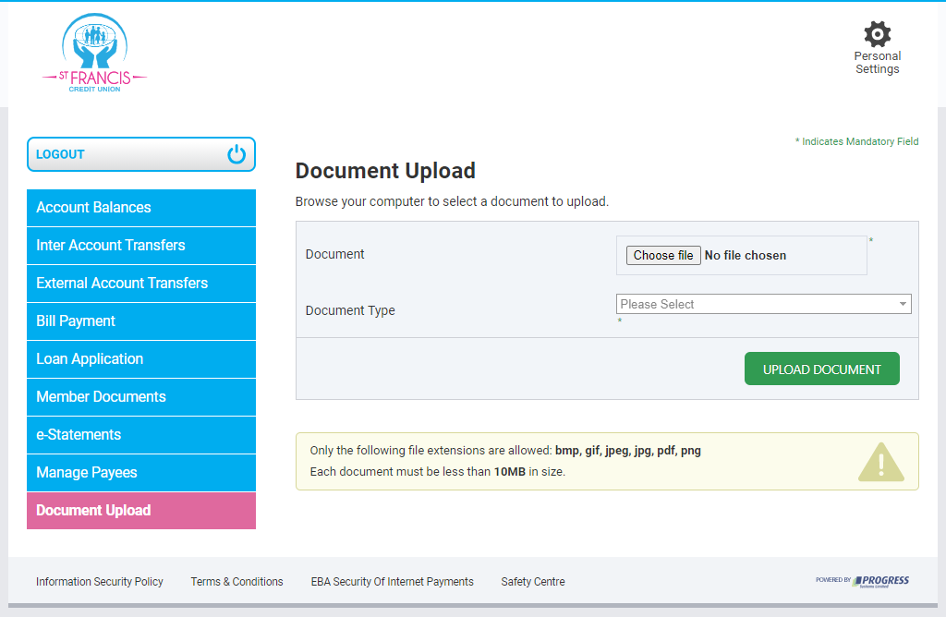

App Version:

- Log on to the SFCU mobile banking app

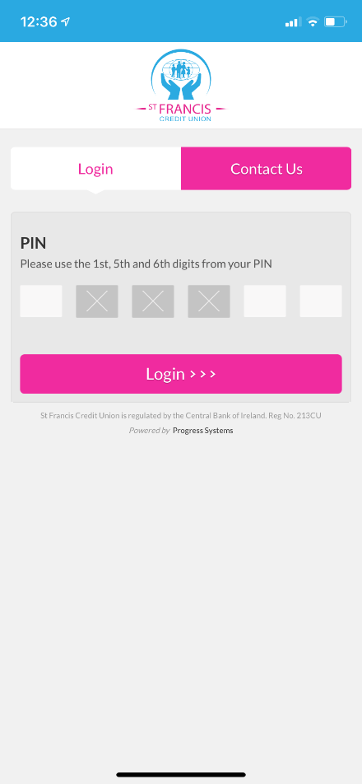

- Select the “Upload Document” button

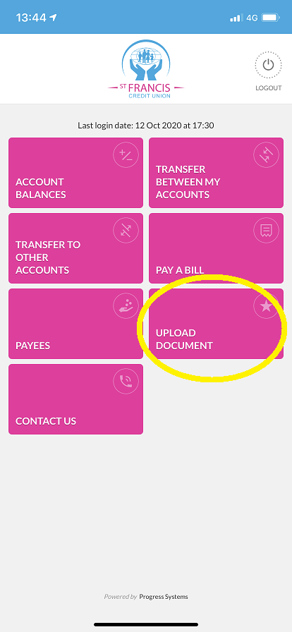

- Member can then select one of the following options:
  - Take a photo
  - Select a Photo
  - Select a file
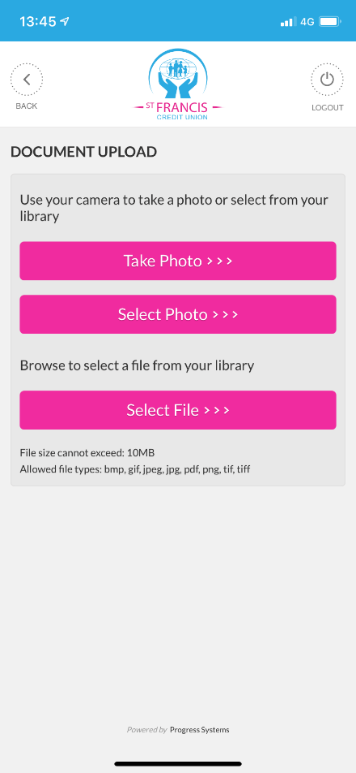
- Once they select the picture, they then need to allocate a “Document Type” from the dropdown menu.
- Once they have selected the picture and document type they press the send button to upload the file.
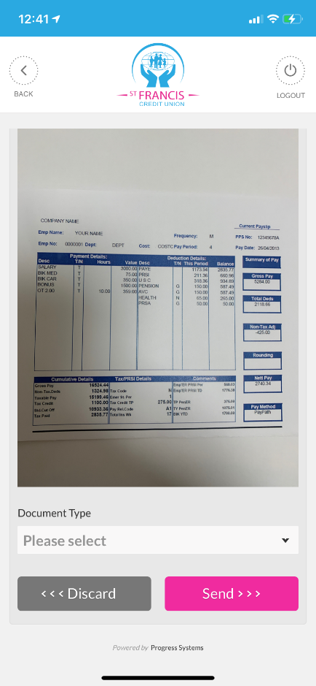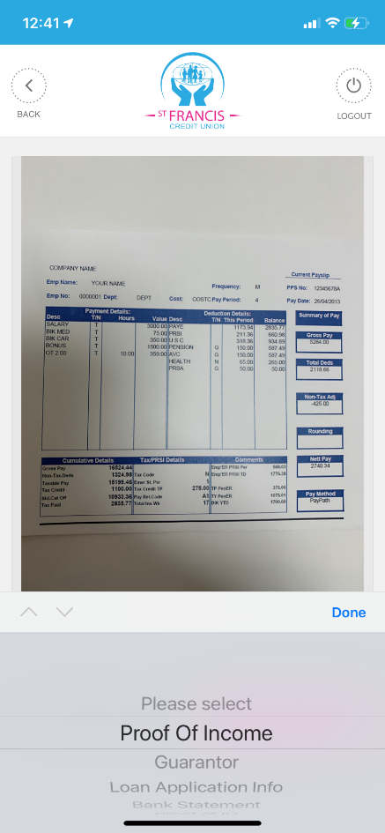

- Member will get the following screen if file is uploaded correctly

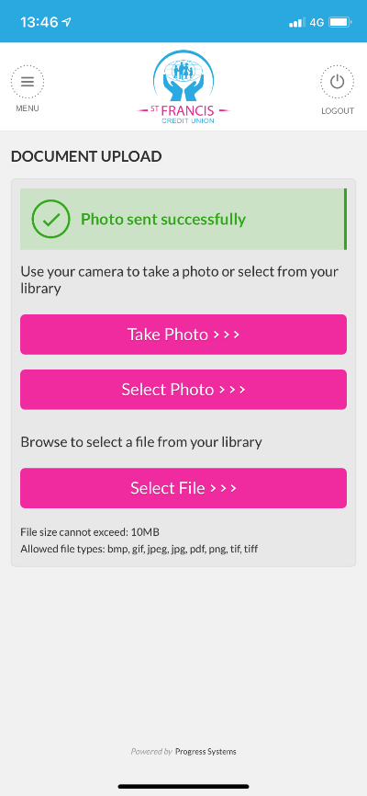

- The documents are now uploaded and will be reviewed by a member of staff.

