Make A Payment
Guide

The Online Payments module allows members to log into the Members Area of the website and transfer funds from their Debit Card to the Credit Union to be lodged into their own accounts, or into another members account.

- Log on to SFCU website and proceed to Login Area.
- Log in with member details to the main Members Area

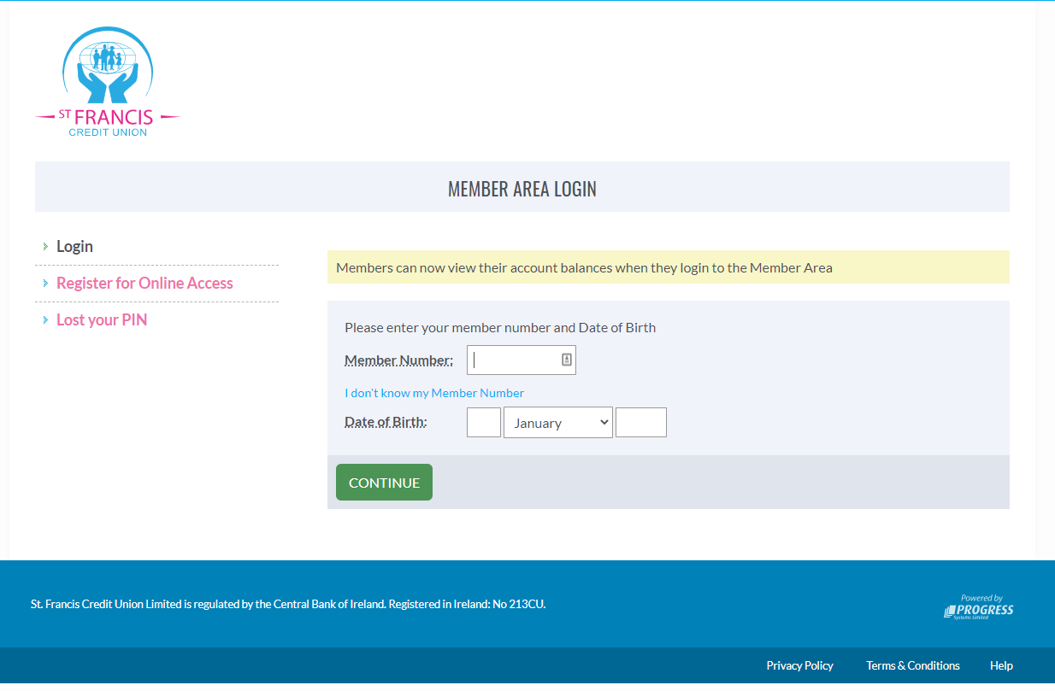
- Launch the online “Make A Payment” section by clicking on the button from the menu bar on the left-hand side.

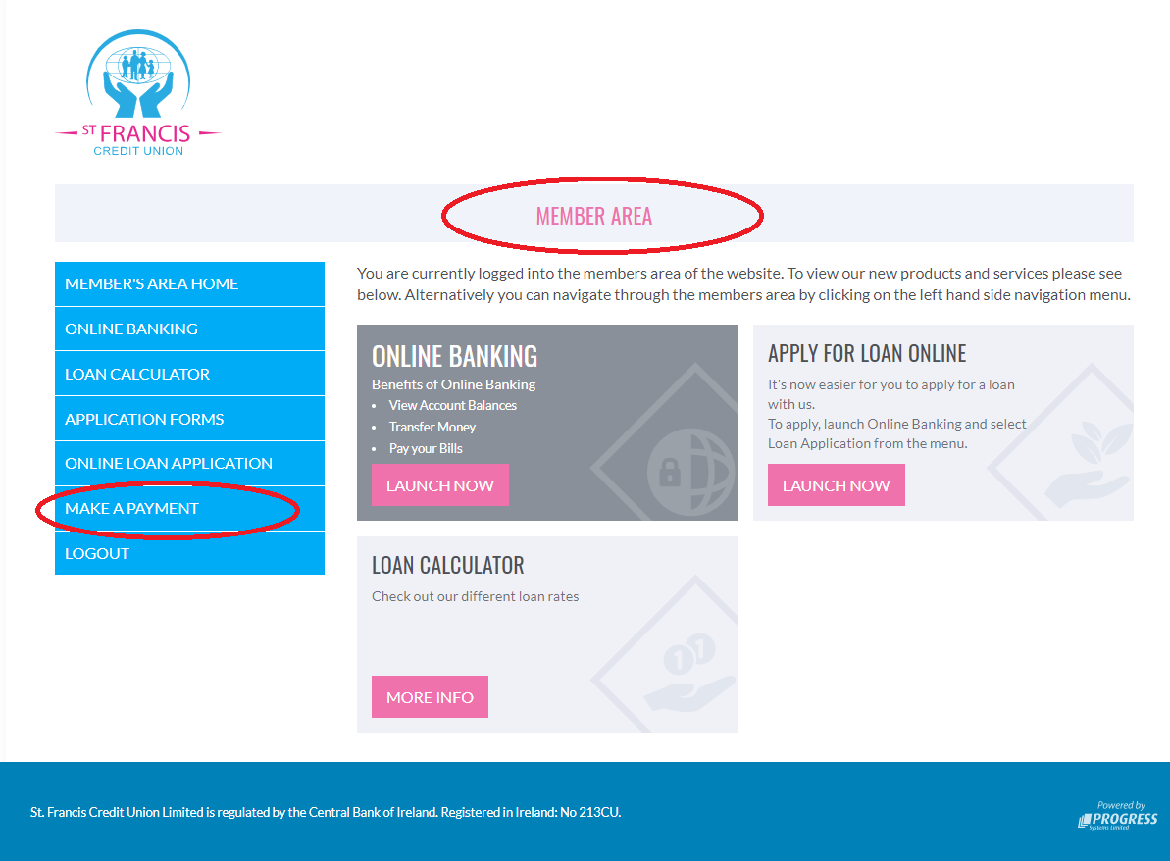

- Once logged into the “Make A Payment” section from two choices
  - Pay into your account
  - Pay another member
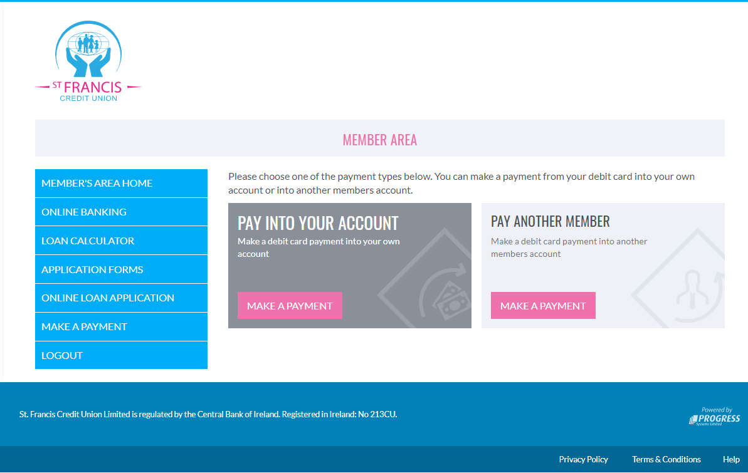

- Pay into your account
When a member selects this option, they will be required to fill in the following information
  - Card Holder Details
  - Billing Details
  - Payment Details
  - Note – all required fields must be completed to continue with process.

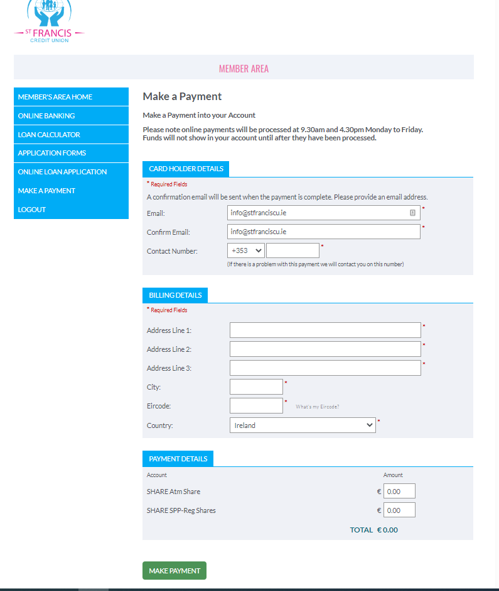
  - Once you have filled out the required details press the “Make Payment” button to continue.

- Pay another account
When a member selects this option, they will be required to fill in the following information
  - Card Holder Details
  - Billing Details
  - Make A Payment
    - Member No. – This is the member number of the account you want to make the payment to.
    - Member Name - This is the member name on the account you want to make the payment to
    - Member Account – This is what section of the members account you would like to payment to go to. i.e. – Share 1 (savings), Loan, ATM etc.
  - Note – all required fields must be completed to continue with process.
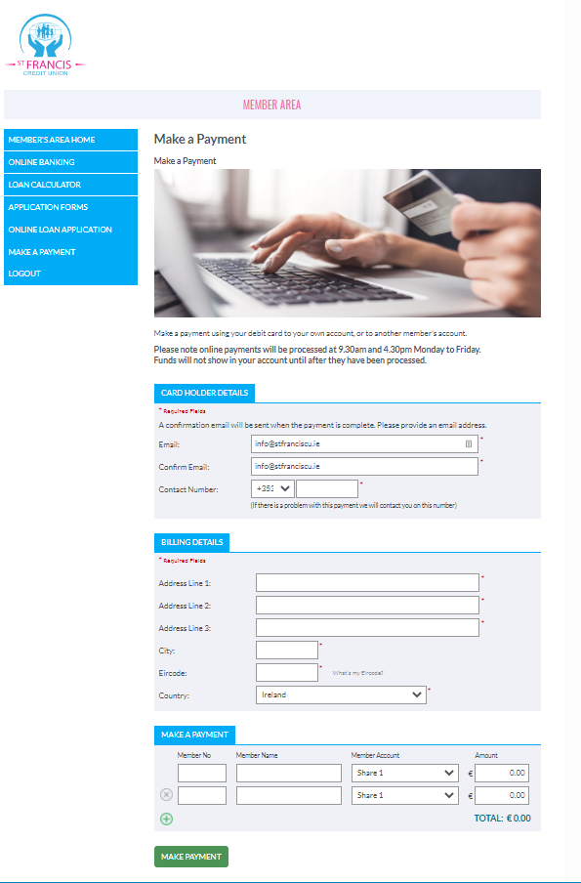
  - Once you have filled out the required details press the “Make Payment” button to continue.
- Once you press the “Make Payment” button you will be forwarded to a secure area where you will be required to enter your Debit Card details.
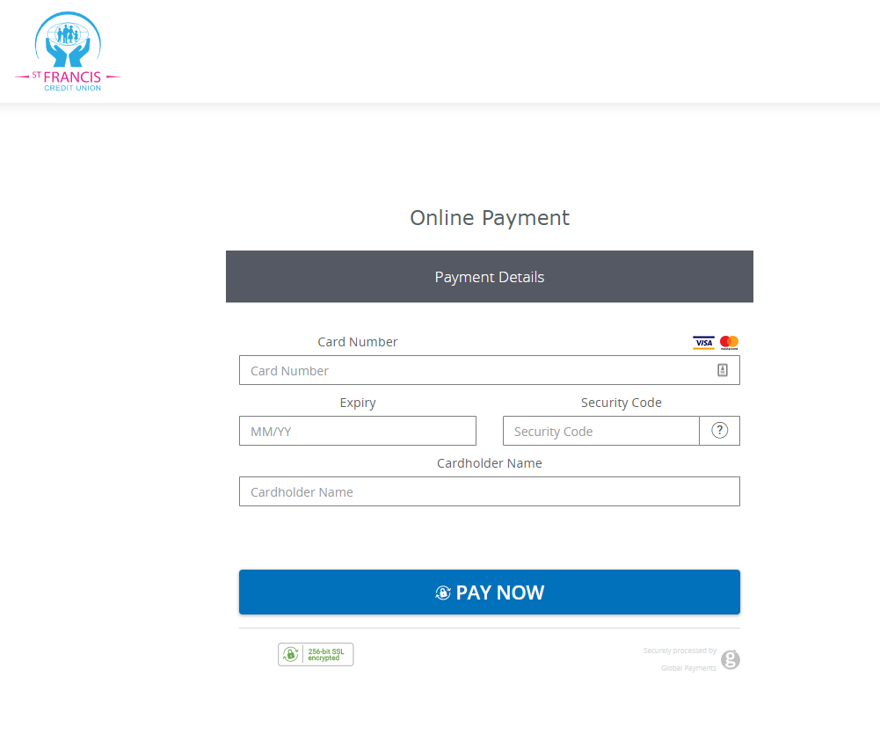
- Click on the “Pay Now” button to proceed
- The system will then to authorise your payment and if authorised you will get notification that your payment was successful.
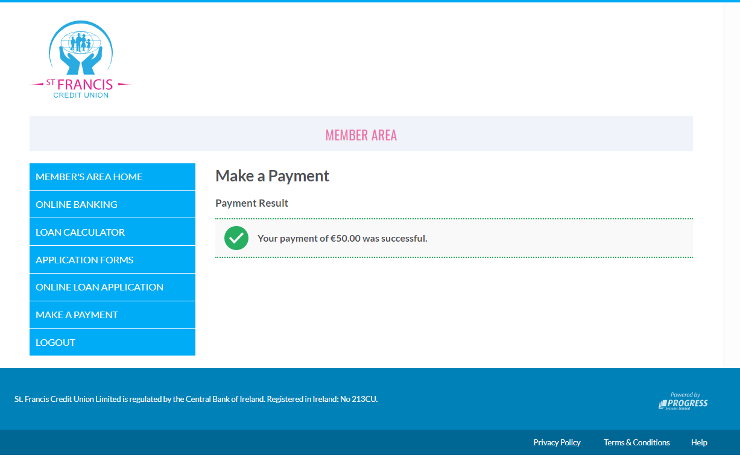
- Payment Process Times
  - Please note online payments will be processed at 9.30am and 4.30pm Monday to Friday. Funds will not show in your account until after they have been processed.

